**INDUSTRIAL INTERNSHIP REPORT ON**

**”prediction of agriculture crops production in india”**

**PREPARED BY**

**Chethana N**

|  |
| --- |
| *Executive Summary* |
| This report provides details of the Industrial Internship provided by upskill Campus and The IoT Academy in collaboration with Industrial Partner UniConverge Technologies Pvt Ltd (UCT).  This internship was focused on a project/problem statement provided by UCT. We had to finish the project including the report in 6 weeks’ time.  My project was (Tell about ur Project)  This internship gave me a very good opportunity to get exposure to Industrial problems and design/implement solution for that. It was an overall great experience to have this internship. |

**TABLE OF CONTENTS**

1 Preface 3

2 Introduction 4

2.1 About UniConverge Technologies Pvt Ltd 4

2.2 About upskill Campus 8

2.3 Objective 9

2.4 Reference 9

2.5 Glossary 10

3 Problem Statement 11

4 Existing and Proposed solution 12

5 Proposed Design/ Model 13

5.1 High Level Diagram (if applicable) 13

5.2 Low Level Diagram (if applicable) 13

5.3 Interfaces (if applicable) 13

6 Performance Test 14

6.1 Test Plan/ Test Cases 14

6.2 Test Procedure 14

6.3 Performance Outcome 14

7 My learnings 15

8 Future work scope 16

# Preface

Summary of the whole 6 weeks’ work.

About need of relevant Internship in career development.

Brief about Your project/problem statement.

Opportunity given by USC/UCT.

How Program was planned

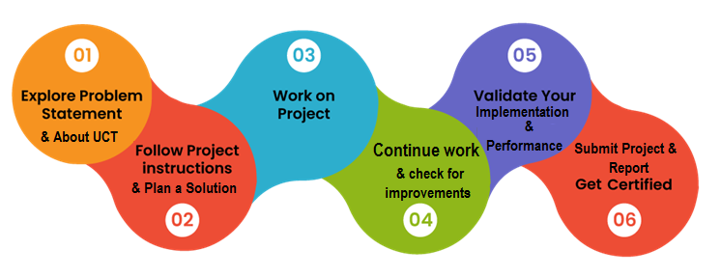

Your Learnings and overall experience.

Thank to all (with names), who have helped you directly or indirectly.

Your message to your juniors and peers.

# Introduction

## About UniConverge Technologies Pvt Ltd

A company established in 2013 and working in Digital Transformation domain and providing Industrial solutions with prime focus on sustainability and RoI.

For developing its products and solutions it is leveraging various**Cutting Edge Technologies e.g. Internet of Things (IoT), Cyber Security, Cloud computing (AWS, Azure), Machine Learning, Communication Technologies (4G/5G/LoRaWAN), Java Full Stack, Python, Front end**etc.

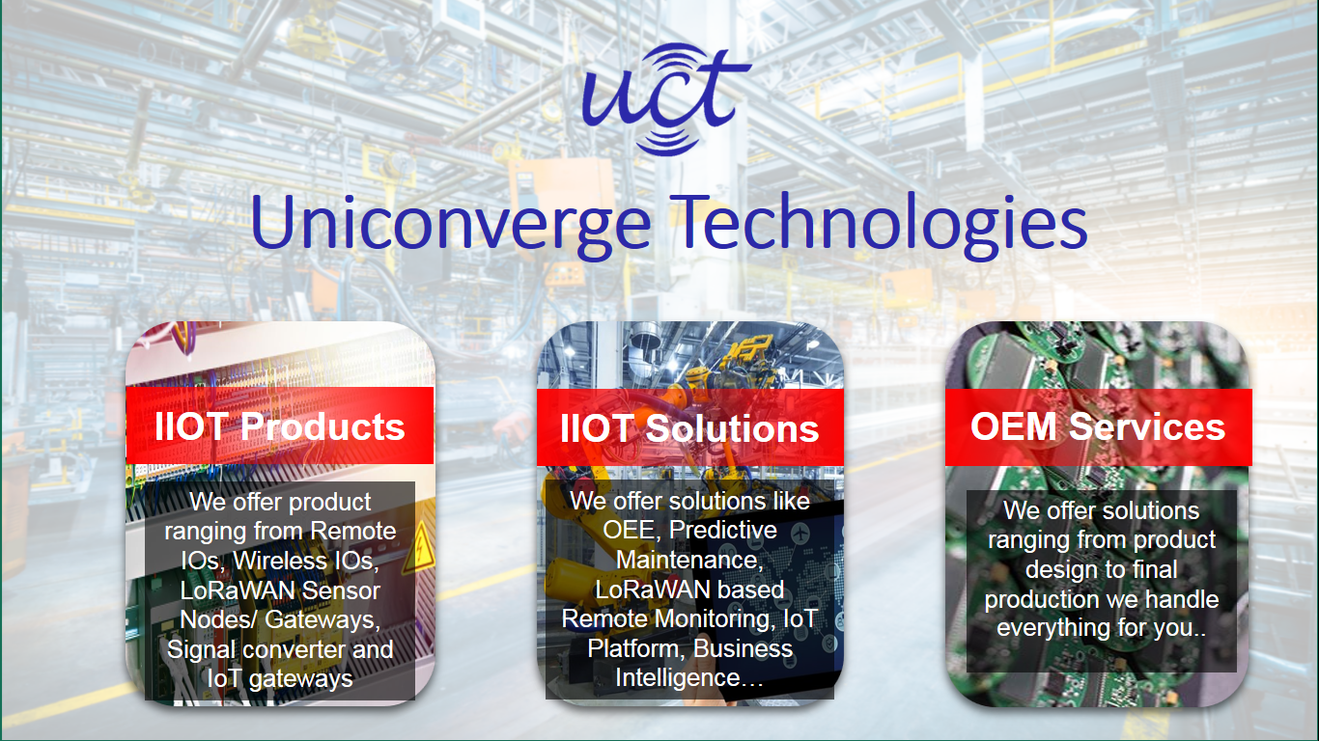

1. UCT IoT Platform **(****)**

**UCT Insight** is an IOT platform designed for quick deployment of IOT applications on the same time providing valuable “insight” for your process/business. It has been built in Java for backend and ReactJS for Front end. It has support for MySQL and various NoSql Databases.

* It enables device connectivity via industry standard IoT protocols - MQTT, CoAP, HTTP, Modbus TCP, OPC UA
* It supports both cloud and on-premises deployments.

It has features to  
• Build Your own dashboard  
• Analytics and Reporting  
• Alert and Notification  
• Integration with third party application(Power BI, SAP, ERP)  
• Rule Engine

 

1. **Smart Factory Platform (****)**

Factory watch is a platform for smart factory needs.

It provides Users/ Factory

* with a scalable solution for their Production and asset monitoring
* OEE and predictive maintenance solution scaling up to digital twin for your assets.
* to unleased the true potential of the data that their machines are generating and helps to identify the KPIs and also improve them.
* A modular architecture that allows users to choose the service that they what to start and then can scale to more complex solutions as per their demands.

Its unique SaaS model helps users to save time, cost and money.

 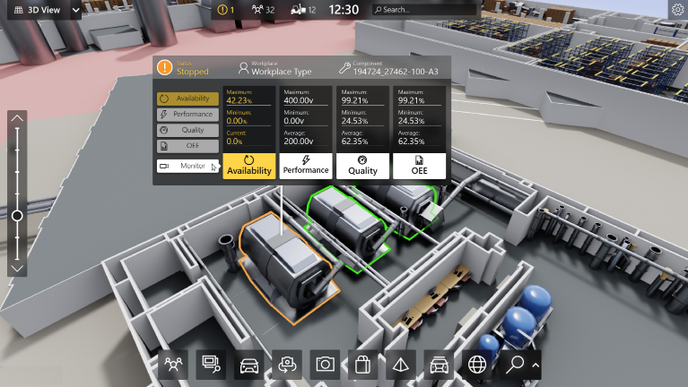

1. 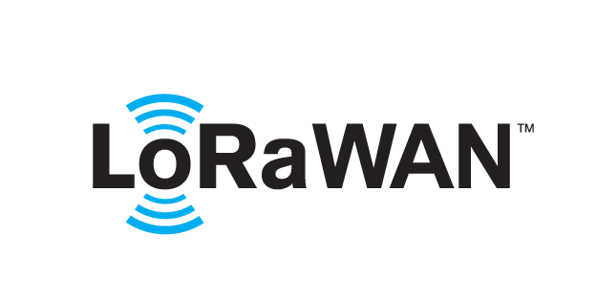 based Solution

UCT is one of the early adopters of LoRAWAN teschnology and providing solution in Agritech, Smart cities, Industrial Monitoring, Smart Street Light, Smart Water/ Gas/ Electricity metering solutions etc.

1. Predictive Maintenance

UCT is providing Industrial Machine health monitoring and Predictive maintenance solution leveraging Embedded system, Industrial IoT and Machine Learning Technologies by finding Remaining useful life time of various Machines used in production process.



## About upskill Campus (USC)

upskill Campus along with The IoT Academy and in association with Uniconverge technologies has facilitated the smooth execution of the complete internship process.

USC is a career development platform that delivers **personalized executive coaching** in a more affordable, scalable and measurable way.



Seeing need of upskilling in self paced manner along-with additional support services e.g. Internship, projects, interaction with Industry experts, Career growth Services

<https://www.upskillcampus.com/>

upSkill Campus aiming to upskill 1 million learners in next 5 year

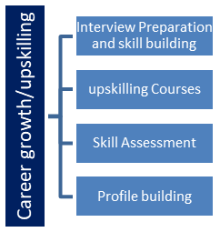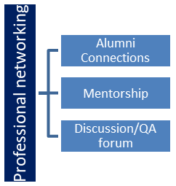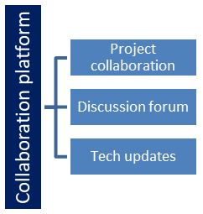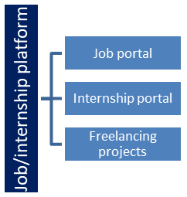

## The IoT Academy

The IoT academy is EdTech Division of UCT that is running long executive certification programs in collaboration with EICT Academy, IITK, IITR and IITG in multiple domains.

## Objectives of this Internship program

The objective for this internship program was to

 ☛ get practical experience of working in the industry.

 ☛ to solve real world problems.

 ☛ to have improved job prospects.

 ☛ to have Improved understanding of our field and its applications.

 ☛ to have Personal growth like better communication and problem solving.

# Problem Statement

In this project, our task is to classify yield variable (target feature) based on the other 17 features step-by- step by going through each day’s task. The evaluation metrics will be RMSE scored.

# Existing and Proposed solution

* identify any existing solutions, strategies, or methods that have been employed to address the problem.
* Evaluate the effectiveness of these existing solutions. Are they successful? What are their strengths and weaknesses?
* Consider the limitations or drawbacks of current solutions. Are there any gaps or areas for improvement?

• **Proposed Solutions**:

* Brainstorm potential new solutions or improvements to existing solutions.
* Consider innovative approaches, best practices, or emerging technologies that could be applied to the problem.
* Prioritize proposed solutions based on their feasibility, potential impact, and cost-effectiveness.

## Code submission (https://github.com/Chethana414/Chethana414)

## Report submission (https://github.com/Chethana414/Chethana414 )

# Proposed Design/ Model

Given more details about design flow of your solution. This is applicable for all domains. DS/ML Students can cover it after they have their algorithm implementation. There is always a start, intermediate stages and then final outcome.

## 5.1Interfaces (if applicable)

reating interfaces for predicting crop yields in Indian agriculture involves the integration of various data sources, technologies, and user-friendly designs to assist farmers, policymakers, and stakeholders in making informed decisions.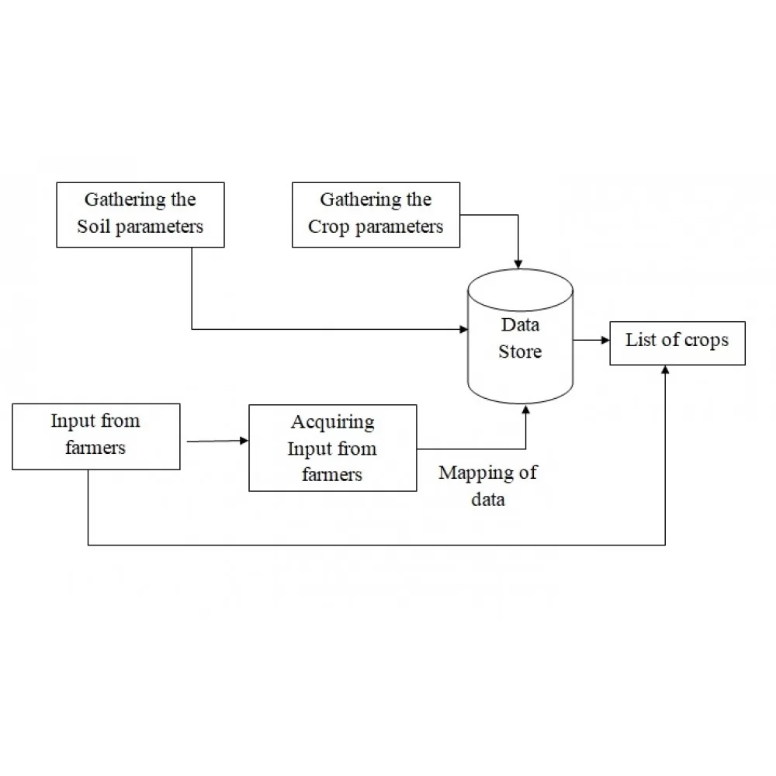**5.2 Performance Test**

This is very important part and defines why this work is meant of Real industries, instead of being just academic project.

Here we need to first find the constraints.

How those constraints were taken care in your design?

What were test results around those constraints?

Constraints can be e.g. memory, MIPS (speed, operations per second), accuracy, durability, power consumption etc.

In case you could not test them, but still you should mention how identified constraints can impact your design, and what are recommendations to handle them.

**6. My learnings**

Predicting crop yields in India is a complex task that involves various factors such as weather, soil conditions, pest and disease management, and farming practices. Here are some key learnings and considerations for predicting crop yields in Indian agriculture:

1. **Data Quality is Crucial**: Accurate predictions depend on high-quality data. Ensure that the data sources for weather, soil, historical crop yields, and other relevant factors are reliable and up-to-date. In many cases, historical data may need to be cleaned and preprocessed to remove outliers and errors.
2. **Machine Learning and Data Analytics**: Utilize machine learning and data analytics techniques to analyze and model the data effectively. Algorithms such as regression, decision trees, and neural networks can be applied to build predictive models.
3. **Feature Engineering**: Identify and engineer meaningful features or variables that can contribute to better predictions. For example, consider creating features that capture seasonal variations, climate anomalies, or soil health indicators.
4. **Local Variability**: India is a vast country with diverse agroclimatic zones. Recognize the local variability in crop yield patterns and tailor your prediction models accordingly. Regional models may be more accurate than a one-size-fits-all approach.
5. **Integration of Remote Sensing Data**: Satellite imagery and remote sensing data can provide valuable insights into crop health, land use, and vegetation indices. Integrating this data can improve the accuracy of yield predictions.
6. **Crop-Specific Models**: Different crops have varying requirements and sensitivities. Develop crop-specific predictive models to account for these differences. Factors like planting date, irrigation, and fertilizer use can significantly impact crop yields.
7. **Real-Time Weather Data**: Incorporate real-time weather data and forecasts into your predictive models. Weather events like droughts, floods, and extreme temperatures can have a significant impact on crop yields.
8. **Soil Health Assessment**: Consider soil health assessments, including nutrient levels, pH, and moisture content. Soil testing can inform recommendations for crop selection and management practices.
9. **Pest and Disease Monitoring**: Integrate pest and disease monitoring systems into your predictive models. Early detection and intervention can mitigate crop losses.
10. **Government Initiatives**: Stay informed about government initiatives and policies related to agriculture. Government data and programs can provide valuable insights and support for predicting crop yields.
11. **Local Knowledge and Expertise**: Engage with local farmers, agricultural experts, and extension services to gather valuable insights and ground truth your predictions. Local knowledge can provide context and validation for your models.

**7.Future work scope**

The future workspace for predicting agriculture crop yields in India is likely to evolve in several ways, incorporating advanced technologies and data-driven solutions to enhance accuracy, accessibility, and usability. Here are some potential developments for the future workspace in crop yield prediction:

1. **Artificial Intelligence and Machine Learning**: AI and machine learning algorithms will continue to play a central role in crop yield prediction. Advanced models, including deep learning techniques, may be employed to improve accuracy and handle complex data interactions.
2. **Big Data and IoT Integration**: The integration of big data and the Internet of Things (IoT) will become more widespread. IoT sensors can collect real-time data on soil moisture, temperature, and crop health, providing valuable inputs for predictive models.
3. **High-Resolution Satellite Imagery**: Advances in satellite technology will provide higher-resolution and more frequent imagery, enabling more precise monitoring of crops and land use changes.
4. **Cloud Computing**: Cloud-based platforms will facilitate the storage and processing of large datasets, making it easier for researchers and stakeholders to access and analyze information.
5. **Blockchain for Data Security**: Blockchain technology may be used to ensure data security and integrity, particularly in cases where sensitive farmer information is involved.
6. **Edge Computing**: Edge computing devices placed directly in the field can process data locally, reducing latency and improving real-time decision-making for farmers.
7. **Mobile Applications**: Mobile apps will continue to be a crucial interface for farmers to access predictive information and receive recommendations. These apps will likely become more user-friendly and offer offline capabilities for areas with limited connectivity.
8. **Natural Language Processing (NLP)**: NLP capabilities may be integrated into interfaces, allowing farmers to interact with the system using voice or text-based queries.